**Experient-3**

**BUS TOPOLOGY**

**Design and Configuration of BUS Topologies using Packet Tracer.**

**Step1:** 3 hubs and 6 PCs

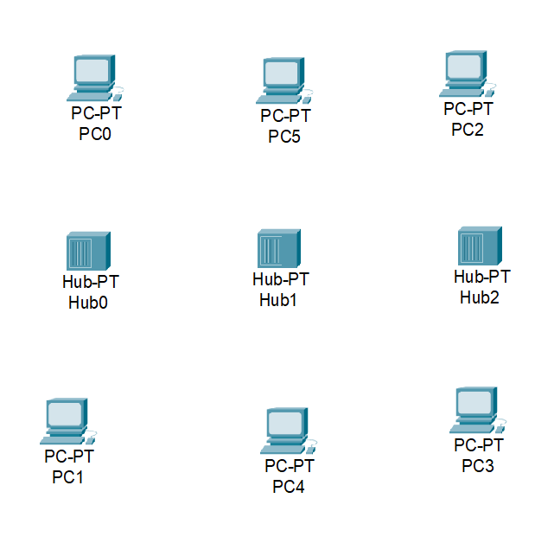

**Step2:** connect fast ethernets from hub to hub and hubs to PCs

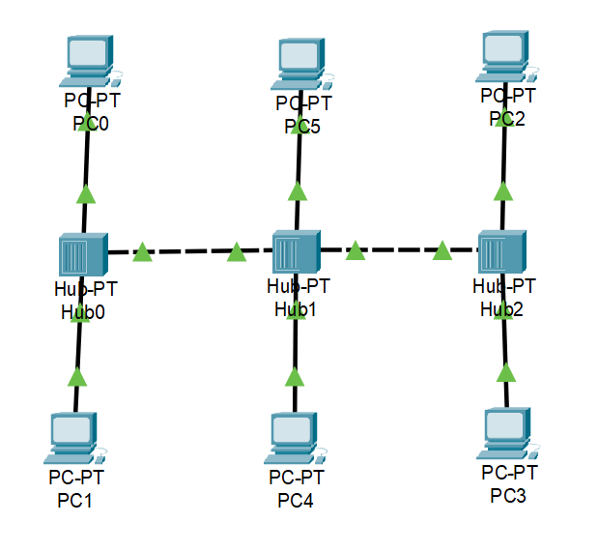

**Step3:** Assign IP address for each PCs

IP address for PC0:192.168.1.1

IP address for PC1: 192.168.1.2

IP address for PC2: 192.168.1.3

IP address for PC3: 192.168.1.4

IP address for PC4: 192.168.1.5

IP address for PC5: 192.168.1.6

**Step4:** allocate the message

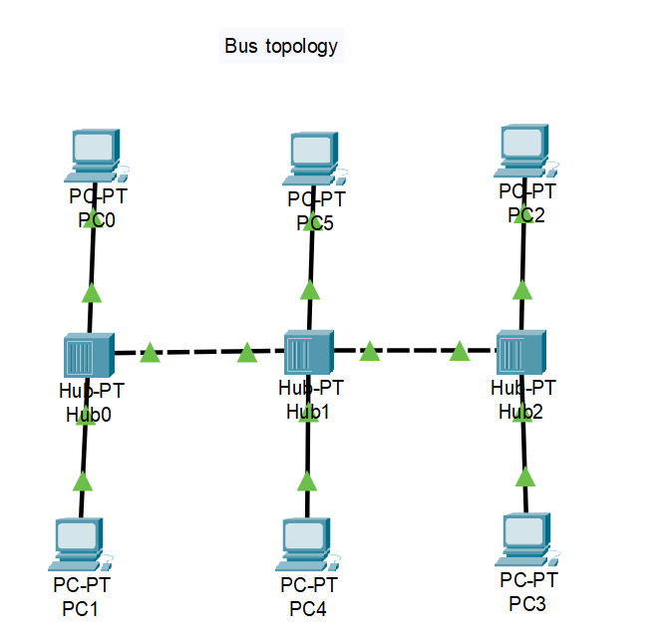

**Result:** message sent successfully from PC1-PC2